Lew Sapieha Award Committee
announces recruitment of candidacies for

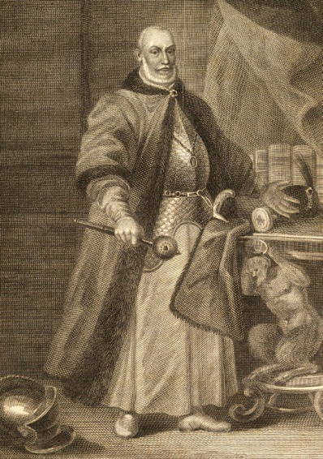
the Award for academic year 2021/22
LEW SAPIEHA AWARD UNDER THE AUSPICES OF THE PRESIDENT OF POLAND
aiming to honour the outstanding contributions of citizens of Belarus to the shaping and development of the civic society in Belarus and construction of a sovereign and democratic state of Belarus – directed towards Europe, taking into consideration the best historical traditions of the Polish–Lithuanian Commonwealth and in the shaping and development of the civic society in Central and Eastern Europe.
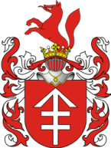
The award was introduced in 2006 by the Centre for East European Studies at the University of Warsaw and the College of Eastern Europe in Wrocław (as initiators of the Award) and taken up and supported by a group of universities: University of Warsaw, Jagiellonian University, Adam Mickiewicz University in Poznań, University of Wrocław and the University of Bialystok. The main feature of the Award is that during an academic year the Laureate of the Award visits universities one after another where, having good living and working conditions, he or she can hold lectures on topics related to the history or present of Belarus – allowing Polish students to get to know Belorussian issues. Moreover, he or she can start their own archiving and research work thanks to an access to the collections of the largest academic libraries in Poland. If the stay of the Laureate bears fruit in the form of a book – it will be published in print as part of the scholarship. The ceremony of the Award takes place at the University of Warsaw every year on 4 April, on the anniversary of the birth of Lew Sapieha – the Patron of the Award, scribe of king Stephen Báthory, chancellor and grand hetman of Lithuania.

Applications containing the description of the contributions and achievements of the candidate – from organisations, institutions, associations etc. or individuals – as well as applications of the candidates for the Award themselves (provided an institution or a person of public trust) are to be sent to the Centre for East European Studies by 1 February 2021 at stypendia.studium@uw.edu.pl

PROGRAMME DEVELOPER
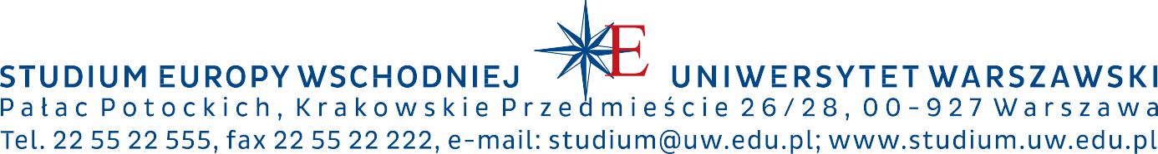
UNIVERSITY OF WARSAW
CENTRE FOR EAST EUROPEAN STUDIES

