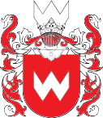

CHAPTER OF IWAN WYHOWSKI AWARD
invites applications for the Main Award and Research Fellowships
FOR ACADEMIC YEAR 2022/23
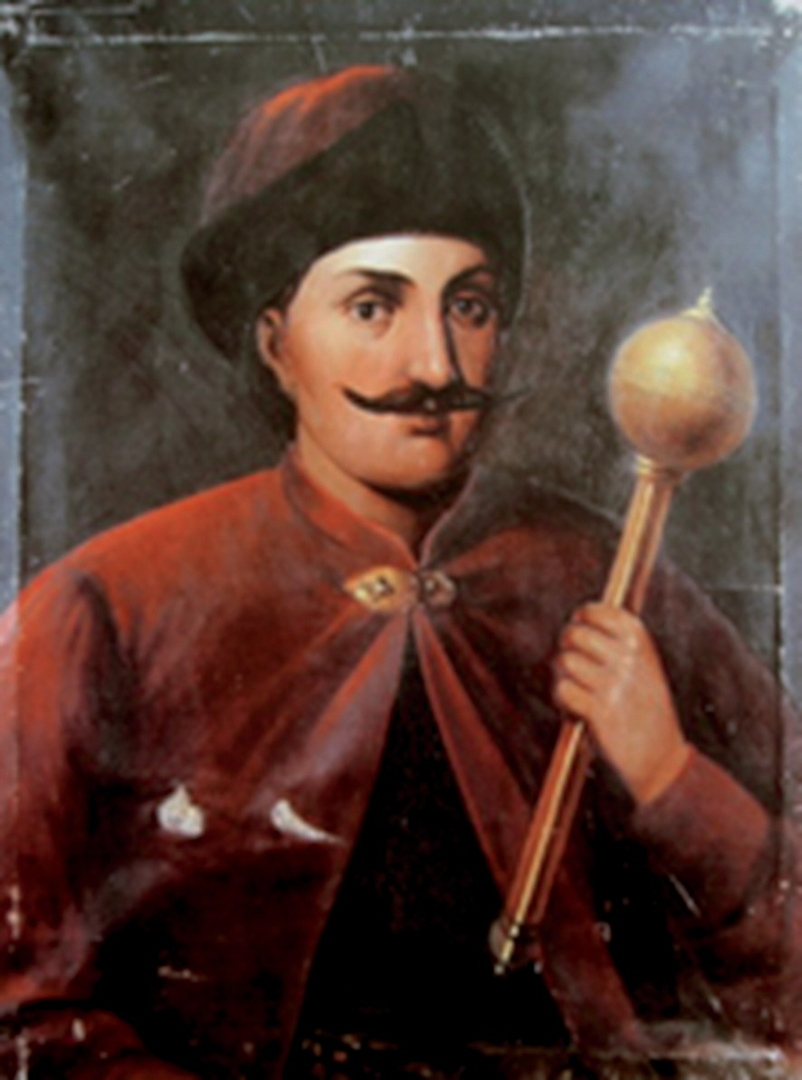

IWAN WYHOWSKI AWARD
- month research and didactic stay at 6 Polish universities for a candidate from the field of the humanities
and

AWARD FELLOWSHIPS
- -month research stays at 2 Polish universities for candidates from the following fields:
  - social studies,
  - exact sciences,
  - economic studies,
  - technical studies,
  - agricultural studies,
  - library science
The programme is jointly funded by 21 Polish universities and research units
The programme is jointly funded by Polish universities and research units.
Applications, containing the description of contributions and achievements of the candidate – from universities, institutes, organisations, institutions, associations etc. or private individuals – as well as applications submitted by the candidates for the Award themselves (provided they are supported by universities, institutes, institutions or individuals of public trust)
are to be sent to the Centre for East European Studies by 15 February 2022 to stypendia.studium@uw.edu.pl

DESCRIPTION
IWAN WYHOWSKI AWARD aims to honour the contributions of Ukrainian citizens in developing science, culture and public life, in shaping and developing civic society in Ukraine and in building democratic Ukraine – turned towards Europe, minding the best traditions of the former Commonwealth and the past, present and future relations of Ukraine with Poland and Europe.
The Award was established in 2014 by: Centre for East European Studies – University of Warsaw (initiator), by the most important Polish universities: University of Warsaw, Jagiellonian University, Adam Mickiewicz University in Poznań, University of Wrocław and four universities located along the Polish eastern Polish border: University of Bialystok, Maria Curie-Sklodowska University in Lublin, Catholic University of Lublin and University of Rzeszów, as well as the College of Eastern Europe in Wrocław and the Ossoliński National Institute in Wrocław.

In the years to come, new universities joined the Award: AGH University of Science and Technology, Kozminski University, College of Europe, Academy of Fine Arts in Kraków, Poznan University of Technology, Warsaw University of Technology, Wrocław University of Science and Technology, Warsaw University of Life Sciences, University of Gdańsk, University of Lodz, Pedagogical University of Krakow, University of Agriculture in Krakow and University of Warmia and Mazury.
The Award Ceremony is held at the University of Warsaw every year on 22 May, on the day when the Sejm approved the Treaty of Hadiach between the Polish–Lithuanian Commonwealth and the Zaporozhian Cossacks in 1659.

The Laureate of the Award, a candidate from the widely understood humanities is given the opportunity of a yearlong research stay at the 6 Polish universities, visited one after another, where they can hold lectures on topics related to the history or contemporary times of Ukraine and the region and Polish-Ukrainian relations and perform their own archiving and research work.

The Award Fellowship will allow Ukrainian researchers in from the above fields to stay at two Polish universities for 4 months as part of a research stay.

QUALIFICATION OF CANDIDATES
- The recruitment of candidates for the Award starts on 1 December.
- The candidates for the Award and the Award Fellowship are to be reported by 15 February
- At a special meeting, the Chapter makes a decision on granting the Award and the Fellowship,
- The stay begins in October of the year when the Award is granted.

DUTIES OF UNIVERSITIES
- scholarship – net PLN 3500 per month (if the Laureate or Fellow has the academic degree of habilitated doctor (DSc) or professor);
- net PLN 2500 per month (if the Laureate of the Fellow has the academic title of MSc or PhD),
- very good living conditions throughout the stay at the given university,
- provision of scientific supervisor/assistance by a tutor from the field of the Laureate at each university,
- books from the press of the hosting universities, in the field of the Laureate,
- Polish course if necessary.

DUTIES OF LAUREATE/FELLOW
- 2 months of stay at each university,
- delivery of one public lectures and, optionally, six course lectures in the institute of affiliation (as decided by the university),
- report on the stay,
- if the stay of the Fellow results in any publications – the Laureate/Fellow will be obliged to place information about the Award in them.

